**Project Design Phase-II**

**Technology Stack (Architecture & Stack)**

|  |  |
| --- | --- |
| Date | 19 October 2022 |
| Team ID | PNT2022TMID30244 |
| Project Name | Project – Car Resale Value Prediction |
| Maximum Marks | 4 Marks |

**Technical Architecture:**

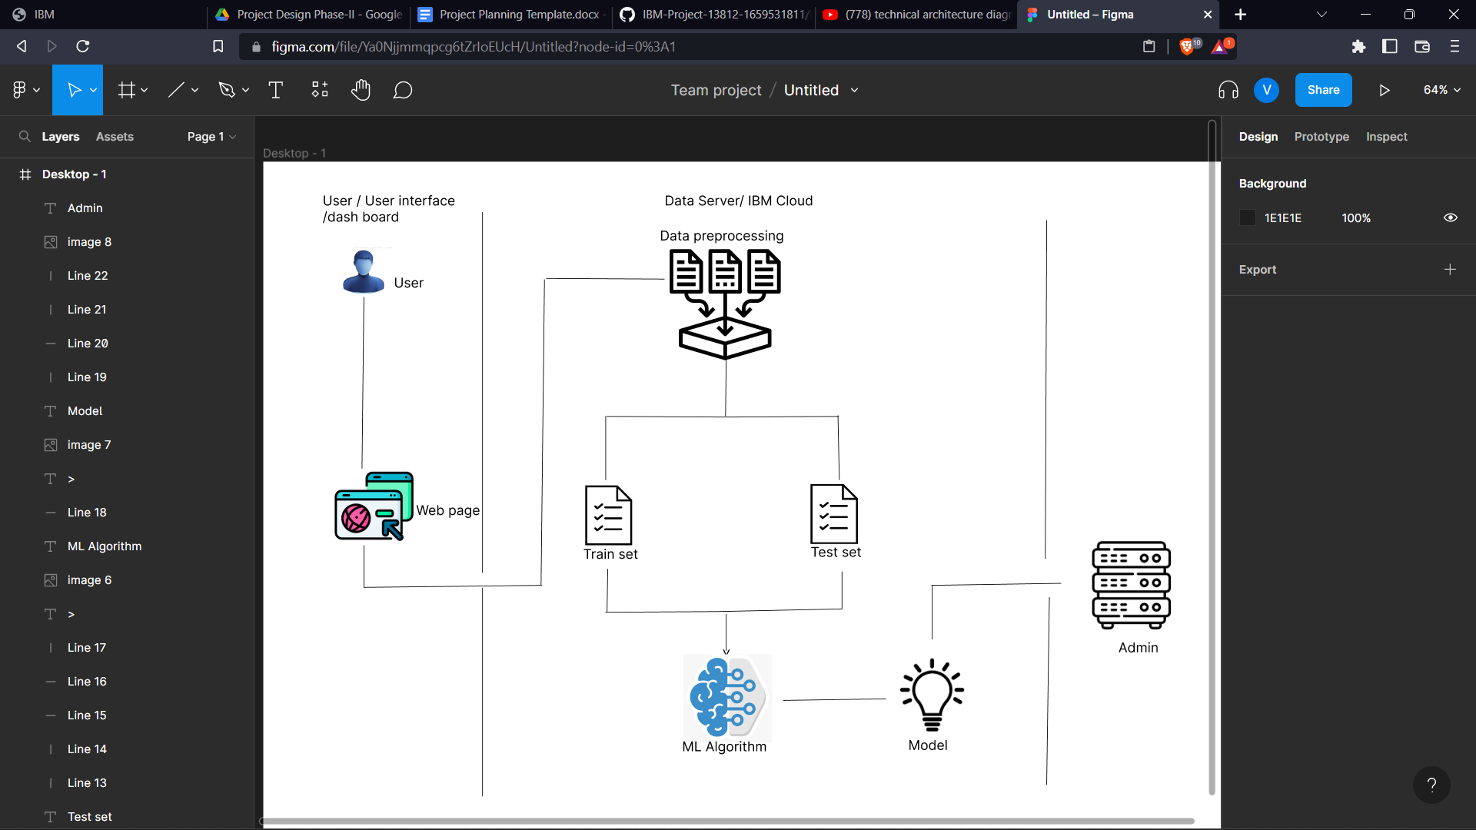

**Table-1 : Components & Technologies:**

|  |  |  |  |
| --- | --- | --- | --- |
| **S.No** | **Component** | **Description** | **Technology** |
|  | User Interface | User Access through web application | HTML, CSS, python flash |
|  | Application Logic-1 | Logic for a process in the application | Python |
|  | Application Logic-2 | Logic for a process in the application | IBM Watson STT service |
|  | Database | Data Type, Configurations etc. | MySQL |
| 5. | Cloud Database | Database Service on Cloud | IBM Cloud etc. |
| 6. | File Storage | File storage requirements | IBM Cloud Local Filesystem |
| 7. | Machine Learning Model | Purpose of Machine Learning Model | Analysis the given data from the customer |
| 8. | Infrastructure (Server / Cloud) | Application Deployment on Local System / Cloud  Local Server Configuration:20 GB of Internal storage  Cloud Server Configuration : 20 GB | Local, IBM Cloud . |

**Table-2: Application Characteristics:**

| **S.No** | **Characteristics** | **Description** | **Technology** |
| --- | --- | --- | --- |
|  | Open-Source Frameworks | Web application frame work | Technology of Opensource framework |
|  | Security Implementations | List all the security / access controls implemented, use of firewalls etc. | e.g. SHA-256, Encryptions, IAM Controls, OWASP etc. |
|  | Scalable Architecture | Justify the scalability of architecture (3 – tier, Micro-services) | Technology used |
|  | Availability | distributed servers. Many customers can assess through our server | IBM Cloud Server |
|  | Performance | Design consideration for the performance of the application (number of requests per sec, use of Cache, use of CDN’s) etc. | Technology used |